**Project Report Template**

**Title of Project:** Apply for All Your Government Documents in One Place  
**Name of the Innovator:** CHARAN V  
**Start Date:** 13-10-2025  
**End Date:** 17-10-2025

**Day 1: Empathise & Define**

**Step 1: Understanding the Need**

**Which problem am I trying to solve?**

I am solving the problem of **complex and time-consuming processes involved in applying for government documents in India**. Citizens often struggle to apply for multiple essential IDs like **Aadhaar Card, PAN Card, Driving License, Voter ID, and Passport** due to different portals, paperwork, and long queues.

My platform — **“Apply for All Your Government Documents in One Place”** — provides a **single, easy-to-use app** where users can apply for multiple government documents digitally with guided steps and real-time status tracking.

**Who is affected by this problem?**  
Indian citizens — especially those in rural or semi-urban areas — who face difficulty navigating multiple government websites, lack digital literacy, or don’t have easy access to service centers.

**How did I find out about this?**  
✅ Interviews  
✅ Observation  
✅ Online Research  
✅ AI Tools

**Step 2: What is the problem?**

The problem is that **citizens need to visit multiple websites or government offices** to apply for essential identification documents. The process is **time-consuming, confusing, and often leads to delays or errors**. There’s no unified digital solution that simplifies the application process for all key government documents in one place.

**Why is this problem important to solve?**

This problem is important because **access to government identity documents is essential** for banking, employment, education, and welfare schemes. Simplifying this process will **save time, reduce stress, and promote digital inclusion** — especially for citizens who struggle with online systems or face accessibility barriers.

**Take-home Task**

**Ask 2-3 people what they think about the project:**

1. **Citizen (Urban User):**  
   “It’s frustrating to use so many different portals for basic documents. Having everything in one app would save so much time and confusion.”
2. **Government Service Agent:**  
   “People often come to us with incomplete forms because they can’t understand the online process. A single guided platform can reduce errors and speed up applications.”
3. **Student (Rural Area):**  
   “I didn’t know how to apply for a PAN Card or Passport online. This app would help people like me do it easily without asking others.”

**AI Tools Used (Step 1 & 2)**

1. **Meta MGX** – Used as a no-code platform to build the unified application system with form flows, authentication, and tracking modules.
2. **ChatGPT** – Used for content design, chatbot flow creation, and form guidance steps for users.
3. **Figma AI** – Used to design simple, mobile-friendly prototypes for the user interface.
4. **Perplexity AI / Google Search AI** – Used to collect information about government documentation processes and required steps.

**Day 2: Ideate**

**Step 3: Brainstorming Solutions**

List at least 5 different solutions (wild or realistic):

1. **Unified Government Portal** – Combine all key document applications in one app.
2. **AI Chatbot Guide** – Help users step-by-step in filling forms and uploading correct documents.
3. **Offline Kiosk Integration** – Allow rural users to access the service via local centers or digital kiosks.
4. **Status Tracker Dashboard** – Show real-time progress for all submitted applications.
5. **Document Storage Vault** – Securely store digital copies of all government documents for future use.

**Step 4: My Favourite Solution**

My favorite solution is **“Apply for All Your Government Documents in One Place”**, a single digital platform where users can apply for Aadhaar, PAN, Driving License, and more through a guided, secure, and simple interface. It ensures smooth form submission, real-time tracking, and a digital vault for safekeeping documents.

**Step 5: Why am I choosing this solution?**

I am choosing this solution because it **simplifies a major pain point for millions of citizens**. It’s practical, scalable, and aligns with the government’s **Digital India** mission. By integrating AI-powered guidance and a unified workflow, users save time, avoid confusion, and gain confidence in completing official procedures digitally.

**AI Tools Used (Step 3–5)**

1. **Meta MGX** – For no-code app creation and workflow design.
2. **ChatGPT** – For drafting help text, chatbot conversations, and guided instructions.
3. **Figma AI** – For user interface mockups.
4. **Canva AI / CoPilot AI** – For creating app visuals and banners.

**Day 3: Prototype & Test**

**Step 6: Prototype – Building My First Version**

**What will my solution look like?**

**Home Screen:**  
Shows categories of documents (Aadhaar, PAN, Passport, etc.) with quick “Apply Now” buttons.

**Smart Chat Assistant:**  
Guides users step-by-step in filling forms, explaining documents needed, and showing sample formats.

**Application Tracker:**  
Displays live status of all submitted applications and estimated completion times.

**Digital Vault:**  
Stores verified e-copies of documents in encrypted format for future use.

**Design Style:**  
Clean, simple, and bilingual (English/Hindi) — designed for accessibility on low-end smartphones.

**Prototype Tools:**  
Built using **Meta MGX**, with guided workflows, user forms, and dashboard screens.

**AI Tools Needed to Build the Solution**

* **Meta MGX:** For interface creation and backend logic.
* **ChatGPT:** To generate help instructions, chatbot flows, and FAQs.
* **Figma AI:** For wireframe design.
* **Canva AI:** For interface banners and icon sets.

**What AI tools I finally selected to build this solution:**  
✅ ChatGPT  
✅ Meta MGX

**<Build The Innovation>**

**<DASHBOARD OF THE TOOL>**  
**Tool Link:** <https://mgx.dev/app/f11ae6f7de3641f5af8e2a5475dcec69>

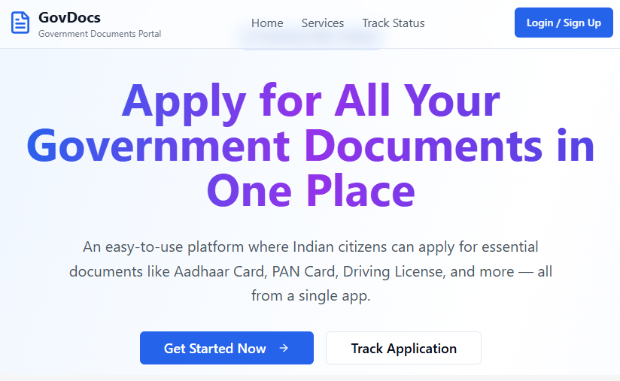

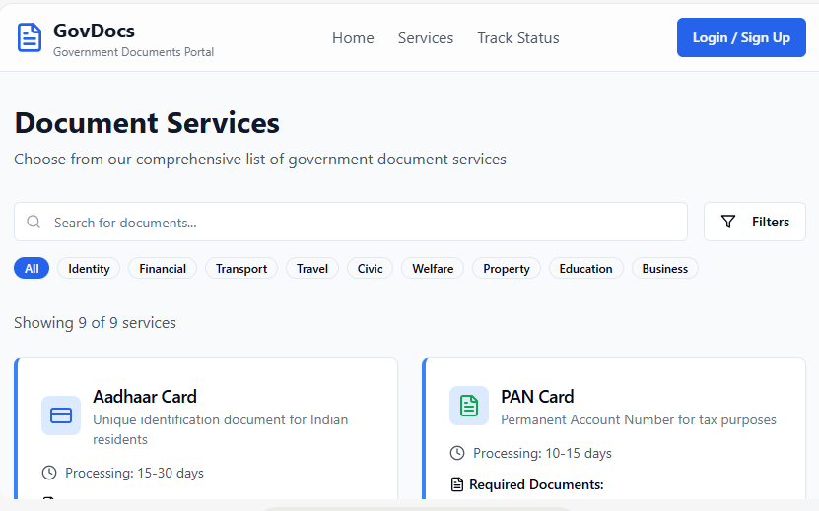

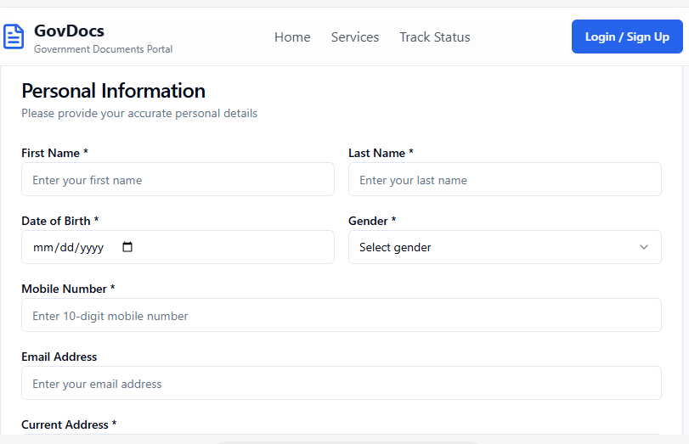

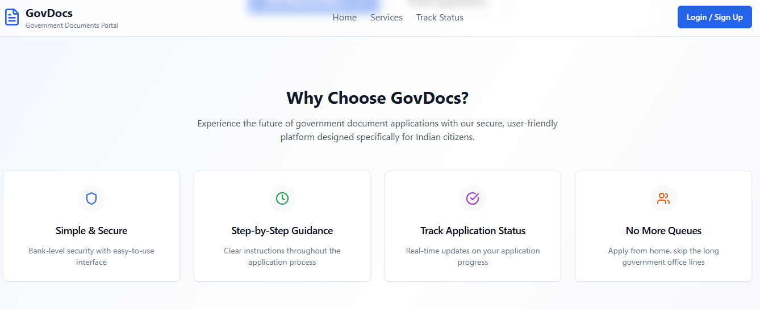

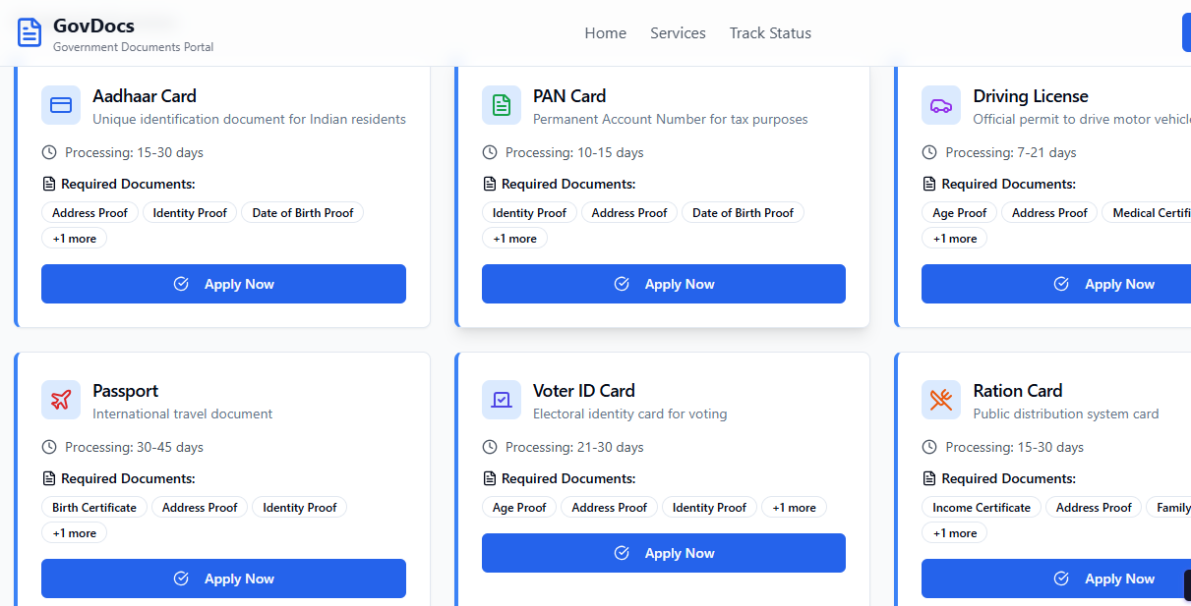

**Internal Working of the Tool:**

**Step 1: User Registration** – Basic details, mobile OTP verification.

**Step 2: Select Document** – Choose from Aadhaar, PAN, DL, etc.  
**Step 3: Guided Application** – AI assistant helps fill the correct form.  
**Step 4: Upload Documents** – User uploads proofs and photos digitally.  
**Step 5: Track Application** – Dashboard shows live status and expected completion.

**Step 7: Test – Getting Feedback**

**Who did I share my solution with?**

* Students and citizens who recently applied for government IDs.
* Cyber café operators and digital service providers.
* Friends and family members from both rural and urban areas.

**Feedback: Pros and Cons**

**Pros:**  
✅ Saves time by combining multiple applications.  
✅ The chatbot makes the process simple even for first-time users.  
✅ Tracking feature is convenient and transparent.

**Cons:**  
🔸 Limited to selected document types in prototype.  
🔸 Needs multilingual support for regional users.  
🔸 Integration with official APIs pending for real submissions.

**My Response:**  
Since this is a prototype built using Meta MGX, certain real-time integrations are not yet functional. With future collaborations with official APIs and government digital services, full automation and multilingual access will be achieved.

**What Works Well**

✅ Single app for all document applications.  
✅ Easy to use, with visual guidance and chatbot support.  
✅ Secure, transparent, and mobile-friendly.  
✅ Saves hours of manual paperwork and travel.  
✅ Built on a no-code platform, allowing easy updates and scalability.

**What Needs Improvement**

🔧 Add regional language support.  
🔧 Integrate with all state-level application systems.  
🔧 Expand cloud storage for digital document vaults.  
🔧 Improve chatbot accuracy for diverse user queries.

**AI Tools Used for Step 6–7**

ChatGPT / Perplexity AI / Meta MGX / Canva AI / Figma AI

**Day 4: Showcase**

**Step 8: Presenting My Innovation**

I am presenting **“Apply for All Your Government Documents in One Place”**, a unified platform that simplifies applying for Aadhaar, PAN, Driving License, and other documents through a single, guided, and user-friendly app.

**Key Features:**

* Smart chatbot for step-by-step application help.
* Real-time status tracking and notifications.
* Secure document vault for easy storage.
* Simple interface designed for all age groups.

**Impact:**  
This innovation supports the **Digital India** initiative by promoting transparency, saving citizens’ time, and making essential government services easily accessible from anywhere.

**Step 9: Reflections**

**What did I enjoy the most?**  
I enjoyed designing a solution that simplifies citizens’ lives and seeing how no-code tools like Meta MGX can make large-scale innovations possible without programming.

**What was my biggest challenge?**  
Integrating real-time APIs and ensuring data privacy were the main challenges. Adapting the platform to serve users across multiple states and languages will be the next step in development.

**Take-home Task:**  
Future scope includes linking the app with official DigiLocker APIs and expanding support for regional languages.

✅ **AI Tools You Can Use for Step 8:**  
Canva AI, Meta MGX, ChatGPT, Figma AI, Gamma AI – to design, document, and present your innovation effectively.